1. Certificates are managed in IIS 8.0 by clicking the root machine node in the left-hand tree-view explorer, and then selecting the "Server Certificates" icon in the feature pane on the right:

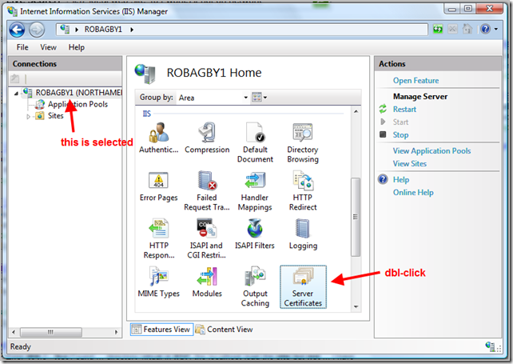

Click on “Create Self-Signed Certificates” icon as displayed in below image:

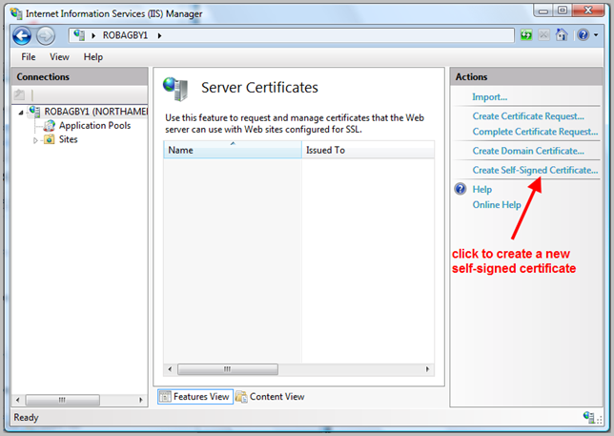

1. On the next screen, enter full URL to your test site (including www but omitting http://)

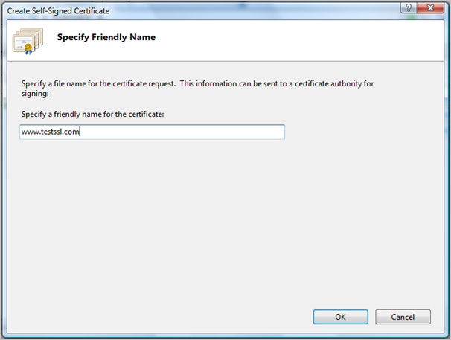

After clicking “OK”, certificate shall be created and be displayed in the Server Certificates window.

1. Enable the HTTPS Binding

In IIS, navigate to your site and choose "Bindings". This will then bring up a dialog that lists all of the binding rules that direct traffic to this site (meaning the host-header/IP address/port combinations for the site):

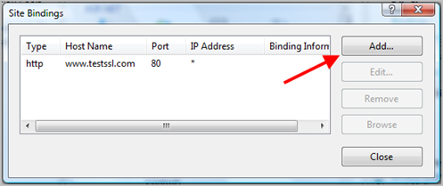

Choose HTTPS and select your certificate from the dropdown list:

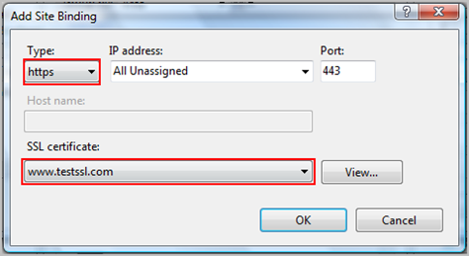

This will enable HTTPS on virtual directory and binding would be displayed as below:

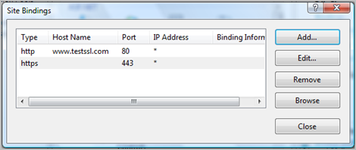

Test the above steps by navigating to the page using<https://localhost/Vision/Avanza.Core.Services/SecurityCacheService.svc>

In most cases, Vision service shall be browsed correctly. However, in case of any error while service browsing, further mentioned steps shall be followed. Sample image of the error is displayed below:

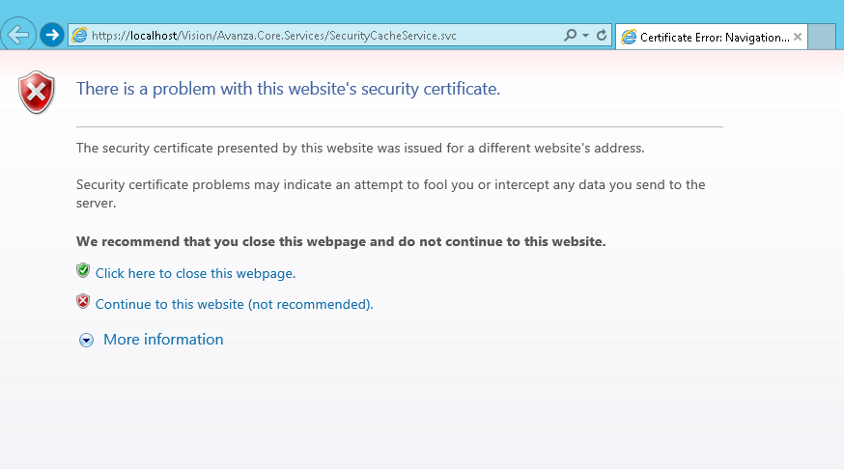

In order to resolve above mentioned error, IIS6 Resource Kit contained a tool called SelfSSL.  By using this utility, self-signed certificate shall be created from the command line.

1. Make sure you have SelfSSL.exe.  If not, you can download it from  [**http://www.microsoft.com/downloads/details.aspx?FamilyID=56FC92EE-A71A-4C73-B628-ADE629C89499&displaylang=en**](http://hansolav.net/blog/ct.ashx?id=0ee46977-c27c-4929-8205-490c84fd649a&url=http%3a%2f%2fwww.microsoft.com%2fdownloads%2fdetails.aspx%3fFamilyID%3d56FC92EE-A71A-4C73-B628-ADE629C89499%26displaylang%3den)
2. Open command prompt (Run as administrator)
3. Navigate to the directory containing SelfSSL.exe
4. In IIS, click on the Sites node to get the site id.  We will pass it as an argument to SelfSSL. Following image displays all virtual directories:

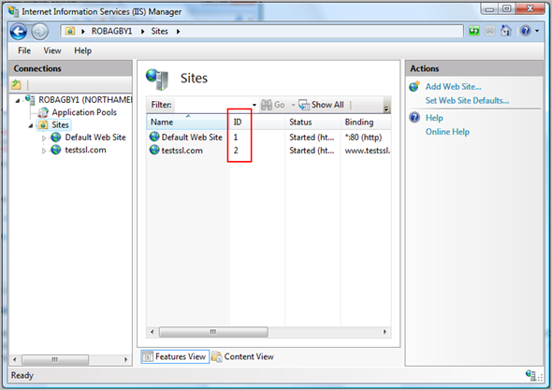

1. Enter the command: SelfSSL /N:CN=<your web site address (no http://)> /V:<how many days the certificate should be valid> /S:<site ID from above> [/P:<port, if not 443>]

Replace required values for information given like <Site ID from above> etc.

Example:  
SelfSSL /N:CN=serverName/IPAddress/V:1000 /S:2

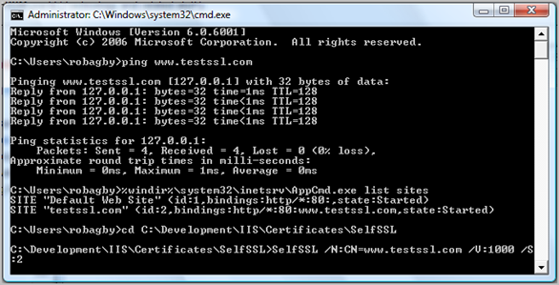

1. Rebind the certificate

Go to Default WebSite> in the right pane then select “Bindings”. Click HTTPSand then select SSL Certificate you created using SelfSSL. This step is mentioned in below image:

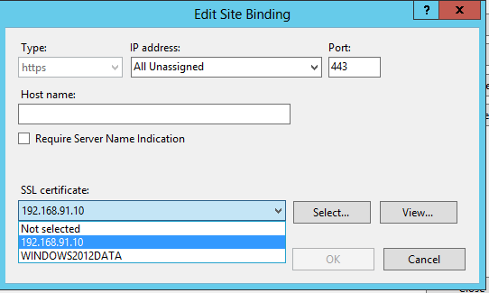

1. Export the certificate

Select server name from left pane in IIS. On right pane, Actions list shall appear. Click on “Export” from the list as identified below:

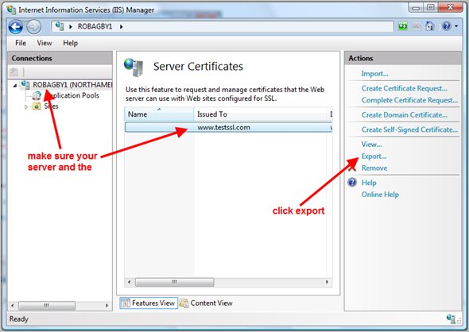

Following dialog window shall appear:

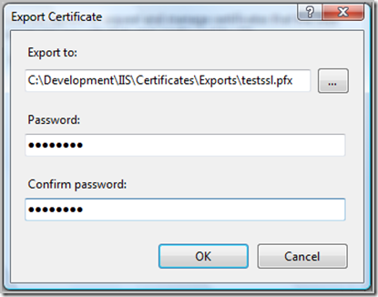

1. Open Certificate Manager. This can be done through clicking Start menu or pressing (Window key + R). On Run dialog window, enter MMC.exe and press Enter.
2. MMC console shall appear. In the console, go to File > Add/Remove Snap-in.

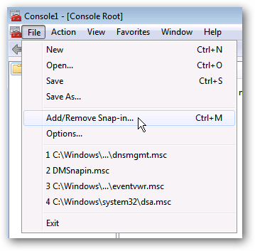

1. Add Certificates from the left side.

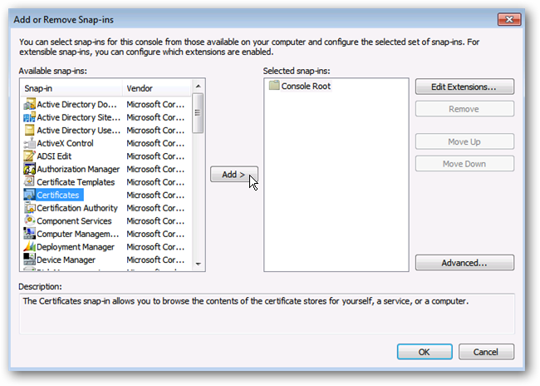

1. Select Computer account.

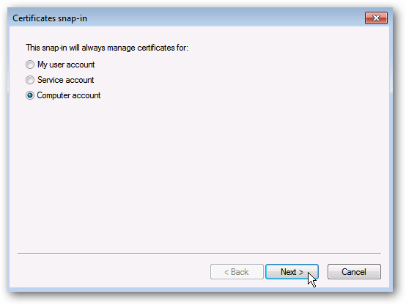

1. Select Local computer.

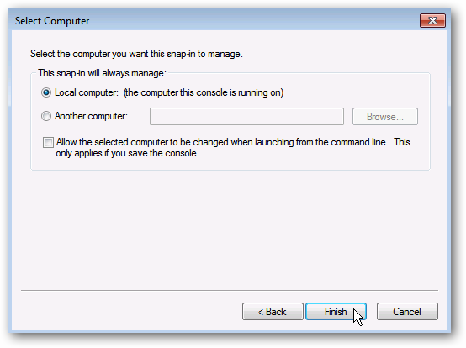

1. Click OK to view the Local Certificate store.

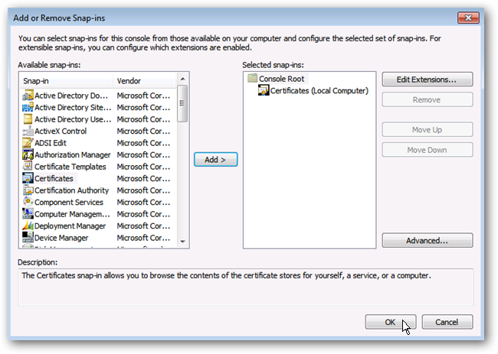

1. Right-Click on "Certificates" under "Trusted Root Certification Authorities" | All Tasks | Import

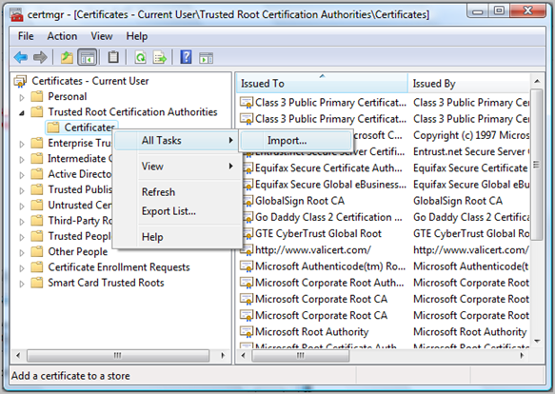

1. Click Next on the splash screen and enter the path to the export you did in the last step (you need to change the file extension choice in the dialog to pfx)

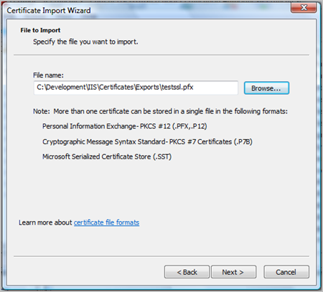

1. Enter the password you created when exporting

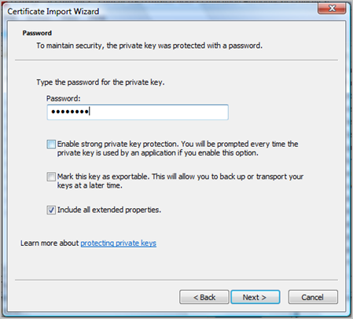

1. On the next screen, click Browse so we can select the appropriate store (Local Machine)

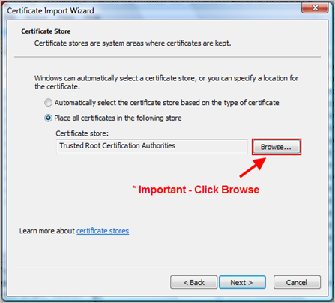

Note: Make sure you select “Certificates” under “Trusted Root Certification Authorities”

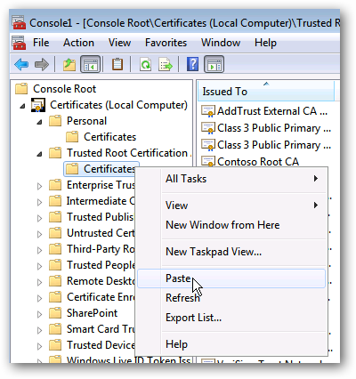

1. Import the same certificate into Personal folder as well

Now, browse the Vision Service and following page shall appear: